Ideation Phase
Empathize & Discover
Date: | 20/12/2025
Team ID:
Project Name: | Book a Doctor – Online Doctor Appointment System
Maximum Marks: | 4 Marks

Empathy Map Canvas
The Empathy Map Canvas is used to understand the needs, emotions, challenges, and behaviors of users interacting with the Book a Doctor platform.
This phase focuses on both patients and doctors, ensuring the system is user-friendly, efficient, and reliable.
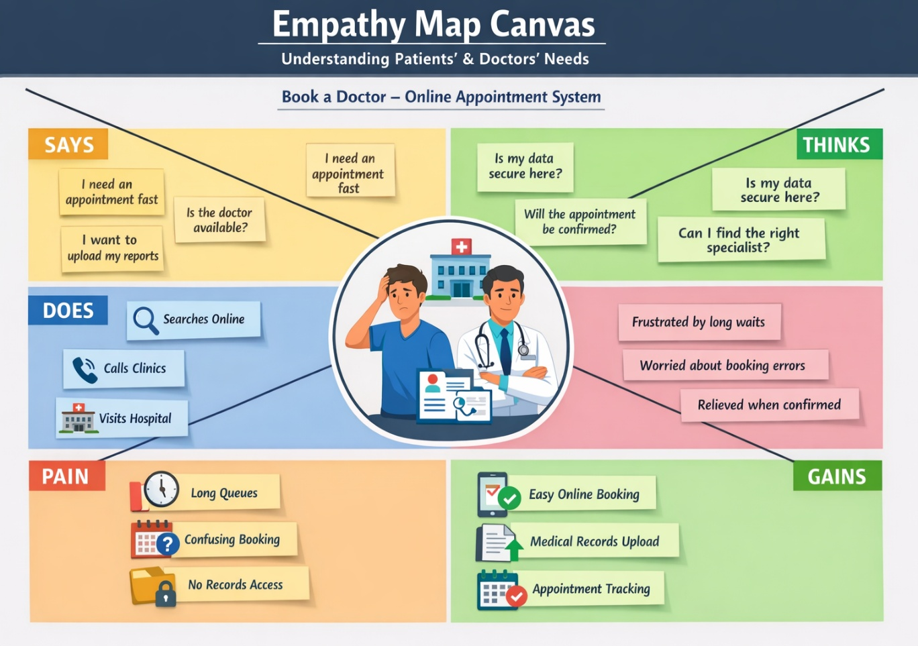

1. Says
- “I want to book a doctor appointment without visiting the hospital.”
- “I need to know doctor availability before booking.”
- “Managing appointments manually is time-consuming.”
- “I want a secure way to share medical documents.”

2. Thinks
- “Is this doctor trustworthy and qualified?”
- “Will my appointment be confirmed on time?”
- “Can I reschedule or cancel easily?”
- “Is my personal and medical data safe?”

3. Does
- Searches online for doctors and clinics
- Calls hospitals to check availability
- Visits hospitals physically for booking
- Doctors review appointments and approve/reject them

4. Feels
- Frustrated by long waiting times
- Stressed due to lack of appointment clarity
- Relieved when appointments are confirmed online
- Confident when doctors can manage schedules digitally

5. Pain Points
- No centralized platform for booking doctors
- Long queues and manual appointment systems
- Poor communication between patients and doctors
- Difficulty in tracking appointment status

6. Gains
- Easy online appointment booking
- Clear appointment status (pending, approved, completed)
- Digital document upload and sharing
- Efficient appointment management for doctors

Insights Gained from Empathy Mapping
Through empathy mapping, the team identified that:
- Patients need simplicity, clarity, and speed
- Doctors need organization and control
- Admins need system-wide visibility and moderation
These insights guided the development of:
- Role-based dashboards (User, Doctor, Admin)
- Appointment approval and status tracking
- Secure authentication and authorization

Reference:
https://www.mural.co/templates/empathy-map-canvas

